TECNOLOGY ARCHITECTURE

Trip based modeling of fuel consumption in modern fleet

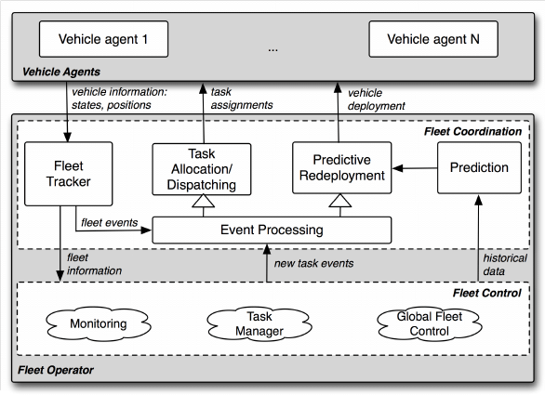vehicles